**UML CLASS DIAGRAM**

**AIM:**

To design the UML class diagrams for the Online Exam Registration System.

**DEFINITION:**

In software engineering, a class diagram in the Unified Modelling Language (UML) is a type of static structure diagram that describes the structure of a system by showing the system's classes, their attributes, operations (or methods), and the relationships among objects.

In the diagram, classes are represented with boxes that contain three compartments:

* The top compartment contains the name of the class. It is printed in bold and centered, and the first letter is capitalized.
* The middle compartment contains the attributes of the class. They are left-aligned and the first letter is lowercase.
* The bottom compartment contains the operations the class can execute. They are also left-aligned and the first letter is lowercase.

**CLASS DIAGRAM:**

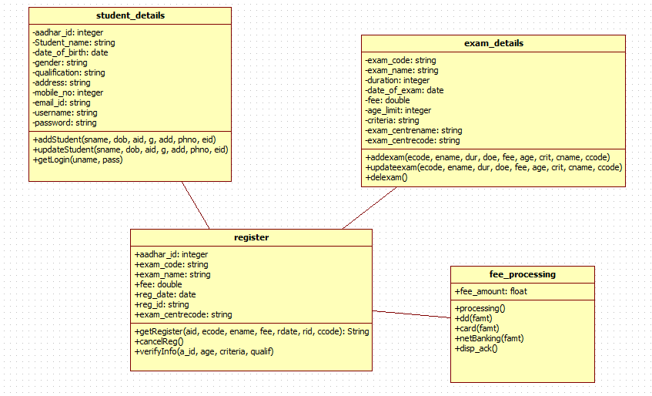

**CLASS DESCRIPTIONS:**

**Student_details:**

In the student_details class, we get all the student details namely, aadhar ID, student name, date of birth, gender, qualification, address, mobile number, email ID, user name and password. The add_student() function is used to add a student to the database and the update_student() function is used to update a particular student’s details. GetLogin() is used by the student to login using his username and password.

**Exam_details:**

In the exam_details class, we get all the exam details from the student. Trhe details for each exam are predefined in the database i.e. the list of exams from which the student can register for and the details of each exam are defined by the administrator. Details like exam code, exam name, duration of the exam, date of the exam, fee, age limit, criteria, exam centre name and exam centre code are given. Add_exam() function is used to select a particular exam to register. Update_exam() function is used to update details of an exam. DelExam() function is used to delete a choice.

**Register:**

The register class is used by the student at the time of registration for a particular exam. This class will inherit all the details like aadhar ID, exam code, exam name, fee, regdate, regid and examcentre_code from student details and exam details classes. GetRegister() function is used to register with all the inherited details. CancelReg() function is used to cancel the registration. The verifyInfo() function is used to check if the student is eligible to register for the particular exam he has chosen. The function uses the student’s aadhar ID to determine the number of times he has previously appeared for the exam, age to check whether his age is within the exam’s age limit, qualification to check whether he is qualified for the exam. Any other criteria set for each exam is also checked and verified to ensure the student’s eligibility for the exam.

**Fee processing:**

This class is used to determine the mode of payment and to pay the fees for the registered exam. The processing() function is used to select the mode of payment form DD, card and netbanking and call the respective functions according to the user’s choice. The display_ack() function is used to display the acknowledgement and receipt for the payment made.

**RESULT:**

Thus the class diagram for the Exam Registration System has been drawn and explained.